**Myntra Data Analysis and insights using Power BI:**

“If you torture data long enough, it will confess to anything”-a very famous quote said by Ronald Coase, Noble prize winning economist.

Guys this quote means the more questions you ask your dataset, it will give you more detailed insights.

So, Hi everyone, I welcome you all to this tutorial on Power BI. Power BI is a business analytics service by Microsoft that allows you to analyze data and share insights. It enables you to connect to various data sources, transform and clean the data, create interactive visualizations, and share reports and dashboards with others. And in this tutorial we are going to use a rich source of data on fashion e-commerce platform and of-course the favorite of yours-**Myntra** having a fascinating collection of data on thousands of products, brands, categories, ratings, reviews, discounts offered and much more.

So before we deep dive into data and start our analysis, let’s first discuss the agenda for today.

AGENDA…

1. Introduction to BI
2. Data visualization & Tools used for data visualization
3. What is Power BI, why Power BI?
4. Components of PBI
5. Architecture of PBI
6. Dashboard Practical

Slide [1. Introduction to BI]

Business intelligence (BI) is the practice of gathering, analyzing, and presenting information in a way that helps businesses make better decisions.

Imagine you're running a store and you want to know which products are selling the most, which customers are buying the most or who are your customers and which days of the week are the busiest. By collecting and analyzing data from your sales records, you can get a better understanding of what's happening in your store and make informed decisions about what products to stock, when to schedule staff, and how to price your products.

Business intelligence tools make it easier to collect, analyze, and present this kind of data, so that businesses can make more informed decisions based on concrete facts rather than gut feelings or guesswork.

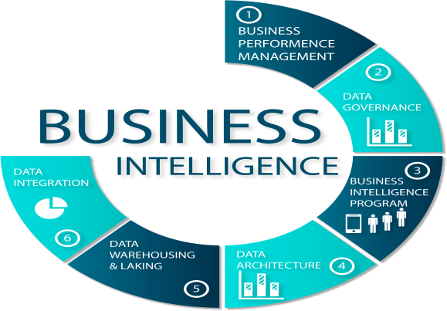

Slide [2. Data visualization & Tools used for data visualization]

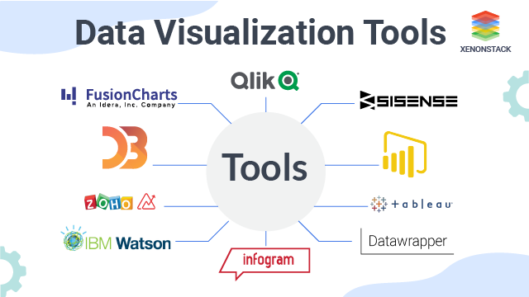

Data visualization is the graphical representation of data and information. It involves creating visualizations, like charts, graphs, maps, and other interactive tools, to help people better understand and interpret data. Data visualization can be used to identify patterns, trends, and relationships in data, as well as to communicate insights and findings to others.

There are a number of tools available for data visualization, some of the top ones include:

1. Tableau: A popular data visualization tool that allows users to create interactive dashboards and visualizations with a wide range of chart types and data sources.
2. Microsoft Power BI: A business analytics service that provides interactive visualizations and business intelligence capabilities with an interface simple enough for end-users.
3. Google Data Studio: A free data visualization and reporting tool that allows users to connect to multiple data sources, create custom reports, and share them with others.
4. Python data visualization libraries: Libraries such as Matplotlib, Seaborn, and Plotly allow users to create complex visualizations in Python code.
5. D3.js: A JavaScript library for visualizing data using web standards. It provides a wide range of data visualization options and customization options.

Now, why do we actually need to use a Business intelligence tool like power BI?

Show live Myntra Website

For answering this question first we will have a look at Myntra website, will try to make possible analysis from it. WEBSITE EXPLANATION (QnA) … But guys what if I want answer for some questions like… we can’t answer these directly by looking this website. And here is where the role of a **BI tools** comes into play.

Slide [3. What is Power BI, why Power BI?]

Now, since there are many BI tools like Tableau, Qlickview etc., then **why POWER BI**?

Power BI is a powerful and popular business intelligence tool that offers a range of features that make it an attractive option for data analysts, business owners, and decision-makers. Here are some reasons why Power BI may be preferred over other BI tools:

1. Integration with Microsoft ecosystem: Power BI is part of the Microsoft ecosystem, which makes it easier to integrate with other Microsoft tools such as Excel, SharePoint, and Teams.
2. Ease of use: Power BI has a user-friendly interface that allows users to easily create interactive reports and visualizations without needing extensive technical skills.
3. Robust data modeling capabilities: Power BI allows users to create complex data models that can handle large datasets and provide insights that are not easily visible in raw data.
4. Integration with cloud services: Power BI integrates seamlessly with cloud services such as Azure and Office 365, making it easy to access and analyze data stored in these services.
5. Interactive dashboards: Power BI enables users to create interactive dashboards that provide a real-time view of key performance indicators (KPIs) and allow users to drill down into the data to gain deeper insights.
6. Collaboration: Power BI allows teams to collaborate on reports and dashboards, share insights, and collaborate on data analysis, making it easier to make data-driven decisions.

Slide[4. Components of PBI]

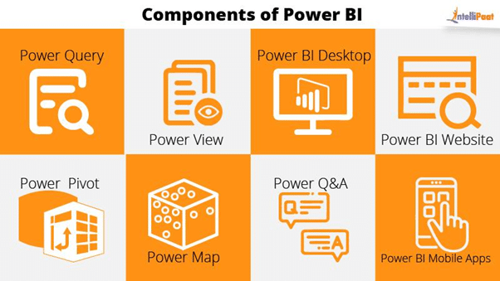

Slide [5. Architecture of PBI]

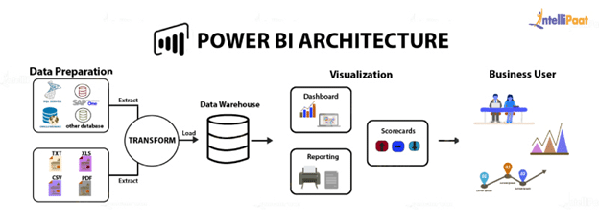

1. Data sources: Power BI can connect to a wide range of data sources, including spreadsheets, databases, and cloud-based services like Azure and AWS. The data sources can be on-premises or in the cloud.
2. Data transformation: Once data is connected, it needs to be transformed into a format that is suitable for analysis. Power BI offers a powerful and user-friendly data transformation tool called Power Query that allows users to clean, reshape, and merge data.
3. Data modeling: Power BI uses a data modeling language called DAX (Data Analysis Expressions) to create relationships between tables, calculate metrics, and create calculated columns and measures.
4. Data visualization: Power BI offers a variety of data visualization options, including charts, tables, maps, and custom visuals. Users can create interactive reports and dashboards that can be shared with others.
5. Data analysis: Power BI offers powerful analytical capabilities, including the ability to slice and dice data, drill down into details, and create ad-hoc reports on the fly.
6. Sharing and collaboration: Power BI allows users to share and collaborate on reports and dashboards with others within and outside their organization. Users can share reports through the Power BI service, embed them in other applications, or export them to other formats such as PDF or Excel.

Slide [6. Dashboard]

And here is the **dashboard** we are going to create today which includes answers of all the questions we asked.

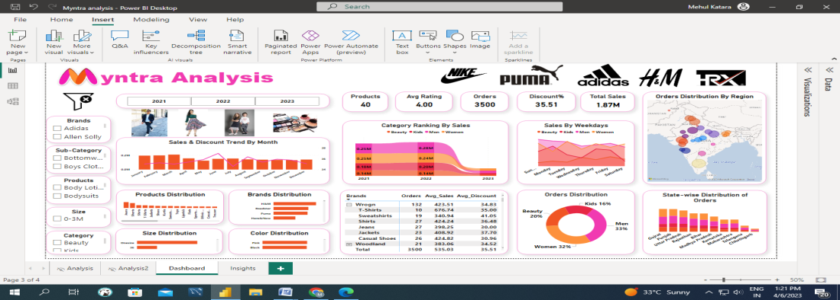

******************************************************************************

**Practical Script:**

1. **Data Import**
2. **Power BI Desktop interface**
3. **Data Cleaning - Power Query Editor (Transform data)**
4. **Calculated columns**
5. **Calculated table**
6. **Measures**
7. **Data Modeling**
8. **DAX**
9. **Basic and advanced charts**
10. **Table & matrix**
11. **How to insert an image and text box in PBI**
12. **How to add Slicers**
13. **Filters**
14. **Bookmarks and selection pane**
15. **Dashboard formatting**
16. **Insights**

**Questions to answer:**

1. **How is Sales percent of different categories changing over years?**

**25% decrease in Sales for women category from Qtr1 to 2, 10% decrease from 2 to 3**

1. **How is ranking percent by sales of different categories changing over years?**

**Men were on rank-1 for years 2021 & 2022 while rank dropped down to 2 in year 2023(data till March). From Jan-Feb men’s rank dropped down from 1 to 3 and women’s rank raised from 2 to 1.**

1. **Which city of Gujrat is placing highest orders?**

**Ahmedabad**

1. **Which color is most popular among males?**

**Black**

1. **Which brand jeans are most purchased by men?**

**H&M**

1. **Which product is most sold by NIKE?**

**Sports Shoes**

1. **Which brand is most popular for beauty products?**

**Loreal**

1. **What is Brand-wise distribution for lipsticks?**

**Highest by Lakme, lowest by MyGlamm**

1. **Which color jackets are least purchased?**

**Red**

1. **Which size products are most commonly sold in kids category?**

**3-4 Years**

1. **Which brand on Myntra is generating highest sales revenue?**

**Puma**

1. **Which brand is offering least discount for women’s jeans?**

**Cantabil**

1. **H&M products are most sold in which city?**

**Bengaluru**

1. **Distribution of products among all states/cities?**

**Map**

1. **Sales & Discount Trend over time(month, year) for each category🡪explain**
2. **Highest sales are made on which day of the week for each category?**

Insights:

**Practical Topics:** <https://www.kaggle.com/datasets/manishmathias/myntra-fashion-dataset>